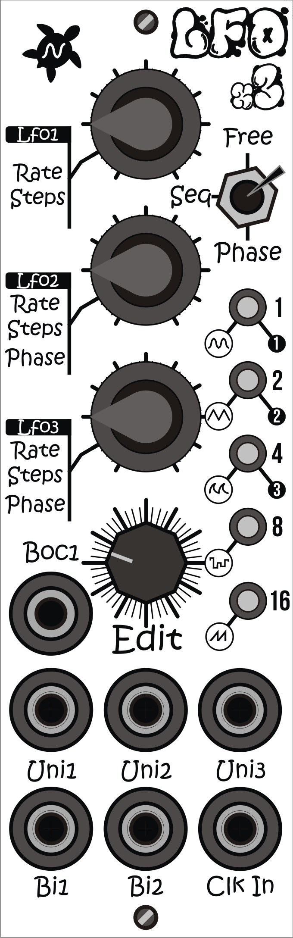

**User’s**

**MANUAL**

*LFO x 3*

September 2020

**Revision Sheet**

|  |  |  |
| --- | --- | --- |
| **Release No.** | **Date** | **Revision Description** |
| Rev. 0 | 26/09/2020 | User’s Manual First revision |
|  |  |  |
|  |  |  |
|  |  |  |
|  |  |  |
|  |  |  |
|  |  |  |

**USER'S MANUAL**

**TABLE OF CONTENTS**

Page #

A. GENERAL INFORMATION 1

​ 1.1 Specifications 1

​ 1.2 Description 2

B. GETTING STARTED 1

​ 2.1 Overview 1

​ 2.2 Usage 2

​ FREE mode 2

​ Phase mode 2

​ Sequencer mode 2

**1.0 GENERAL INFORMATION**

# GENERAL INFORMATION

## 1.1 Specifications

* Format: Eurorack
* Dimensions: 8HP, 60mm deep
* Internal and external signals: 0-5V Logic I/O
* Max Current:
  1. +12V: 50mA
  2. -12V: 1mA
  3. +5V: n/a

## 1.2 Description

LFOx3 is a 3 channel digital low frequency oscillator module. Each LFO channel can be used independently or in one of three synchronized modes. The total frequency range spans from 105 seconds up to 150Hz.

In Sequencer mode, each channel outputs a sequence of a controllable number of steps sampled from the selected waveform. If saw waveform is selected, the output will increase with each Clock Input signal. If noise waveform is selected, the output can be used as a sample&hold for generating random values.

Features

* 5 Waveforms
  + Sine
  + Triangular
  + Exponential
  + Noise
  + Saw
* 8 bit output signal @ 10Khz sampling rate.
* Digital Clock Input.
* Beginning of cycle Output.
* Unipolar and Bipolar Outputs.
* Three modes:
  + Free mode: Select a waveform and rate for each channel.
  + Phase mode: Select a rate for 3 channels and the phase shift for channel 2 and 3.
  + Sequencer mode: Select an amount of steps (1 to 31) for each channel. Rate is given by Clock input.

**2.0 GETTING STARTED**

# GETTING STARTED

## 2.1 Overview

**Mode switch:** Selects the current mode.



**Knob LFO1:**In free mode, sets the Channel 1 frequency. In Phase mode, sets the main frequency. In Sequencer mode, sets the number of steps for channel 1.

**Leds:**Indicate selected channel, waveform type and steps.

**Knob LFO2:**In free mode, sets the Channel 2 frequency. In Phase mode, sets phase shift. In Sequencer mode, sets the number of steps for channel 2.

**Unipolar outputs:**

Unipolar outputs (0V..5V) for channel 1,2 and 3.

**Knob LFO3:**In free mode, sets the Channel 3 frequency. In Phase mode, sets phase shift. In Sequencer mode, sets the number of steps for channel 3.

**BoC1:**Outputs a pulse each time the channel 1 signal starts its cycle.

**Clk In:**

In free and phase mode, syncs the output signals. In Sequencer mode advances the current step for all channels.

**Bipolar outputs:**

Bipolar outputs (-5V..5V) for channel 1 and 2.

**Edit:**

Encoder for selecting channel and waveform.

## 2.2 **Usage**

**Encoder:** Move the encoder to select a channel. Leds will indicate 1, 2 or 3. Then click the encoder to activate the selected channel. The current waveform will be shown. Move the encoder to change the waveform. Click the encoder to go back to channel selection.

### FREE mode

Move the switch to “Free” position. The frequency for each channel can be set by Knob1, 2 and 3. The waveform for each channel can be set by the encoder.

All channels can by synced using the Clk input.

BoC output will trigger at the beginning of channel 1 cycle.

### Phase mode

Move the switch to “Phase” position. The main frequency for all channels can be set by Knob1. The waveform for each channel can be set by the encoder.

Use knob2 to set the phase shift between channel 1 and 2 from 0 to 180º.

Use knob3 to set the phase shift between channel 1 and 3 from 0 to 180º.

Channel 1 can by synced using the Clk input.

BoC output will trigger at the beginning of channel 1 cycle.

### **Sequencer** mode

Move the switch to “Seq” position. The main frequency for all channels will depends on Clk input signal and the amount of steps selected for each channel.

Use knob1 to set the amount of steps for channel 1, knob2 for channel 2 and knob3 for channel 3.

The selected waveform will be sampled with that amount of steps each time a Clk in signal arrives.

BoC output will trigger at the beginning of channel 1 cycle.